Instructions to test the board

1.Check the position of the jumpers before power the board

J1- 2&3 CLOSED

J2- 2&3 CLOSED

J3- Open

J4- Closed

J5- 2&3 CLOSED

J6- 2&3 CLOSED

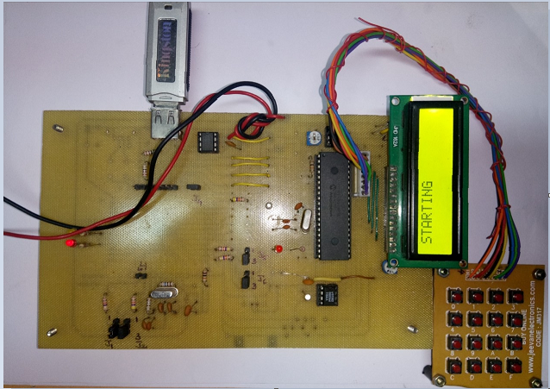

2. Connect the prototype board to 5 volt/500ma DC Power supply

“STARTING “ message will be displayed in the LCD. Wait for sometime till Press 1 to Start message displayed.

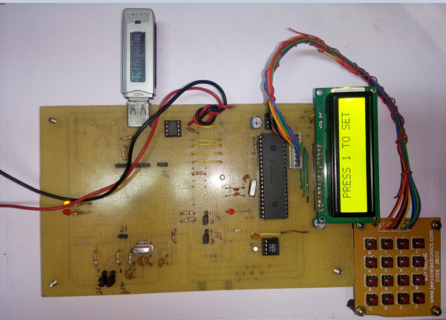

3.Press 1 in the key board

4.Press 18 for the year

5. Press 09 for the month

6.. Press 08 for the day

7. Press 01 Weekday(Sunday)

8.Hour Press 08( Present time in hours say 8a.m)

9.Minute Press 30 (Present time in minutes say 30minutes)

10.Start Hour taking measurement Press 08

11. Start minute taking measurement Press 32

12. Stoppage of measurement in hours(END HR)Press08

13. Stoppage of measurement in min(END MIN)Press35

14.Duration of taking measurement in hours. Press 00

15. Duration of taking measurement in minutes .Press 01.

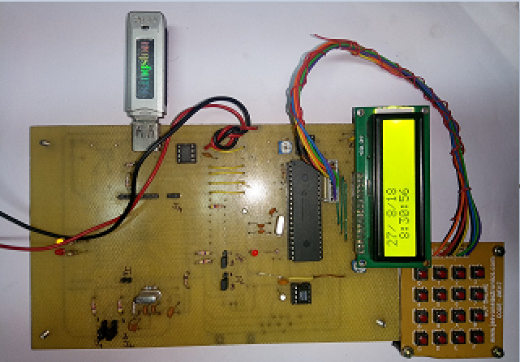

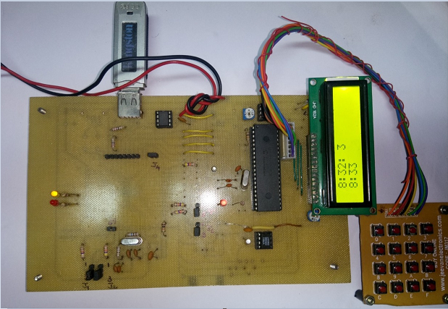

Remove the pen drive and the “Results” file can be opened using Excel Program. Once the measurement is over again the required parameters can be entered to carry out one more measurements. The proto type board was tested with Scandisk 16GB, Sony 32GB, HP 16/32GB to mention a few.

Note:

I request you to do the testing as it is. After that you can re program the micro controller with the new hex file and again do the testing. Programming VNCL1 using the ROM file needs patience since it may take one or two attempt to complete it.

,

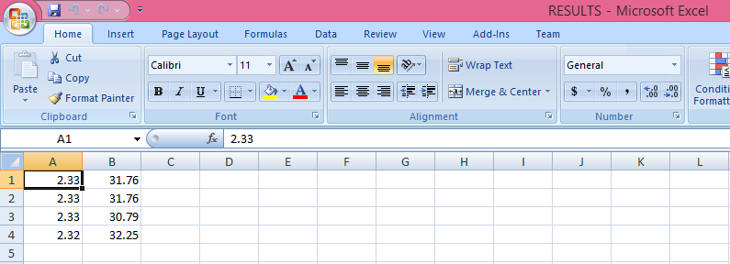

The first column shows the potentiometer reading and the second column shows temperature readings.